ADDIS ABABA UNIVERSITY

FACULTY OF BUSINESS & ECONOMICS
DEPARTMENT OF MANAGEMENT

A Term Paper Submitted in partial fulfillment of the course Marketing Management (MBA-622)

THE ASSESSMENT OF IMPACT OF ADVERTISEMENT ON VIEWERS OF VARIOUS AGE GROUPS: A CASE OF ETV ADVERTISEMENTS

SUBMITTED TO: DR. RAKESH BELWAL
ASSISTANT PROFESSOR
DEPARTMENT OF MANAGEMENT

SUBMITTED BY:

MAY 2006
Checklist

- Prepare the title page as suggested
- Give referencing using bibliographical conventions
- Don’t forget to write an abstract.
- Attempt a good introduction and conclusion.
- Softcopy is also required with hard copy.
- First draft (corrected) need to be necessarily attached (however, you can re- use the bindings in the main paper to save resources)
- Your presence is mandatory for submission.

Follow APA guidelines for formatting:
( see http://owl.english.purdue.edu/owl/resource/560/01/) if you want to learn more.
Your essay should be typed, double-spaced on standard-sized paper (8.5 X 11 inches) with margins of 1 inch on all sides. Your final essay should include, in the order indicated below, as many of the following sections as are applicable, each of which should begin on a separate page:
Title page: as mentioned above

Font should be: Times new Roman
Main body text size of font: 12 point
Page numbers and running head: in the upper right-hand corner of each page, include a 1-2 word version of your title. Follow with five spaces and then the page number.
Abstract: Write a 75-100 word overview of your essay, which should include your main idea and your major points. You also may want to mention any implications of your research. Place the abstract on its own page immediately after the title page. Center the word Abstract and then follow with the paragraph.
Headings: Although not absolutely necessary, headings can be helpful. Major headings should be centered. Capitalize every word in the heading except articles (a, the), short prepositions (in, by, for), and coordinating conjunctions (and, but, or).
Visuals: Visuals such as tables and figures include graphs, charts, drawings, and photographs. Try to keep the visuals as simple as possible and clearly label each visual with an Arabic numeral (ex: Table 1, Table 2, etc.) and include the title of the visual. The label and the title should appear on separate lines above the table, flush left. Below the table, provide the source. A sample Figure treatment is shown below.
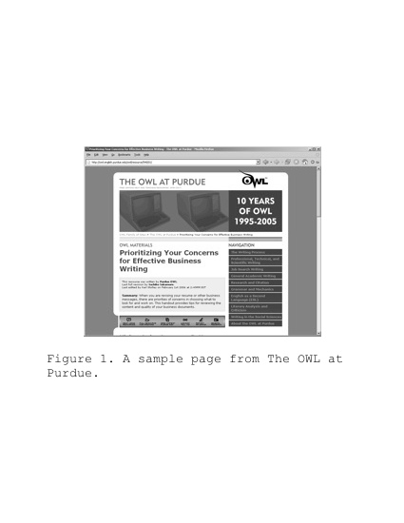
Image Caption: A sample figure and caption in APA style.
List of References: Create your list of references on its own page after the last page of your text. Center the title References one inch from the top of the page. Double space. Alphabetize the list of references by the last name of the authors. If the work as no author or editor, alphabetize the work by the first word of the title (excluding A, An, or The).
For more information about formatting an APA style paper, consult the publication manual, visit APA Style Essentials, or view a Sample APA Report or an APA Simulated Journal Article. Annotated bibliography writers might want to visit APA Format for Annotated Bibliographies. (Additional formatting resources, including Microsoft Word templates, are available in our Additional Resources section.)

Reference List: Basic Rules
Your reference list should appear at the end of your paper. It provides the information necessary for a reader to locate and retrieve any source you cite in the body of the paper. Each source you cite in the paper must appear in your reference list; likewise, each entry in the reference list must be cited in your text.
Your references should begin on a new page separate from the text of the essay; label this page References (with no quotation marks, underlining, etc.), centered at the top of the page. It should be double-spaced just like the rest of your essay.

Basic Rules
- Authors' names are inverted (last name first); give the last name and initials for all authors of a particular work unless the work has more than six authors. If the work has more than six authors, list the first six authors and then use et al. after the sixth author's name to indicate the rest of the authors.
- Reference list entries should be alphabetized by the last name of the first author of each work.
- If you have more than one article by the same author, single-author references or multiple-author references with the exact same authors in the exact same order are listed in order by the year of publication, starting with the earliest.
- When referring to any work that is NOT a journal, such as a book, article, or Web page, capitalize only the first letter of the first word of a title and subtitle, the first word after a colon or a dash in the title, and proper nouns. Do not capitalize the first letter of the second word in a hyphenated compound word.
- Capitalize all major words in journal titles.
- Italicize titles of longer works such as books and journals.
- Do not italicize, underline, or put quotes around the titles of shorter works such as journal articles or essays in edited collections.
The following rules for handling works by a single author or multiple authors apply to all APA-style references in your reference list, regardless of the type of work (book, article, electronic resource, etc.)

Single Author
Last name first, followed by author initials.
Berndt, T. J. (2002). Friendship quality and social development. Current Directions in Psychological Science, 11, 7-10.

Two Authors
List by their last names and initials. Use the "&" instead of "and."
Wegener, D. T., & Petty, R. E. (1994). Mood management across affective states: The hedonic contingency hypothesis. Journal of Personality & Social Psychology, 66, 1034-1048.

Article From an Online Periodical
Online articles follow the same guidelines for printed articles. Include all information the online host makes available.
Author, A. A., & Author, B. B. (Date of publication). Title of article. Title of journal, volume number(issue number if available). Retrieved month day, year, from http://www.someaddress.com/full/url/

